ECAO3O5- SIGNALS AND SYSTEMS
NAME: S.GOKUL
REG NO: 192512373

Experiment No.: 1
Title: Generation and Classification of Continuous-Time and Discrete-Time Signals
Objective (i) To generate and visualize basic continuous-time signals such as unit step, unit impulse, ramp, sinusoidal, and exponential signals.
AIM
To generate and visualize basic continuous-time signals such as unit step, unit impulse, ramp, sinusoidal and exponential signals using MATLAB.
APPARATUS / SOFTWARE REQUIRED
1. Computer / Laboratory PC
2. MATLAB software (with Signal Processing environment)
THEORY
A continuous-time (CT) signal is defined for every value of time t. The basic (elementary) CT signals are the unit impulse, unit step, ramp, exponential and sinusoidal signals.
The unit impulse δ(t) is zero for all t ≠ 0 and has unit area concentrated at t = 0. In simulation it is approximated by a very narrow pulse of one sample width. The unit step u(t) equals 1 for t ≥ 0 and 0 for t < 0. The ramp r(t) = t·u(t) increases linearly with unit slope for t ≥ 0. The decaying exponential is x(t) = e^(−at)u(t), and the sinusoid is x(t) = A sin(2πf₀t + φ) with period T₀ = 1/f₀.
FORMULAE USED
δ(t) = 0 for t ≠ 0; u(t) = 1 for t ≥ 0, 0 for t < 0
r(t) = t·u(t)
x(t) = e^(−at)u(t)
x(t) = A sin(2πf₀t + φ), T₀ = 1/f₀
Percentage deviation = |Practical − Theoretical| / |Theoretical| × 100
PROCEDURE
- Start MATLAB and open a new script file.
- Define the continuous time vector t = −1 to 1 s with a step of 0.001 s.
- Generate the unit impulse, unit step, ramp, exponential and sinusoidal signals.
- Plot each waveform against time using subplot with suitable amplitude and time scales.
- Add title, axis labels and grid to every plot.
- Run the program and measure the amplitude, frequency and period from the sinusoid.
- Compare the simulated waveforms with their theoretical expressions and record the observations.

PROGRAM (MATLAB CODE)
% Experiment 1: Generation of Continuous-Time Signals
clc; clear; close all;
t = -1:0.001:1;
A = 2; f0 = 5; a = 1;
imp = double(abs(t)<0.0005);
step = double(t>=0);
ramp = t.*step;
expSig = exp(-a*t).*step;
sinSig = A*sin(2*pi*f0*t);
figure;
subplot(3,2,1); plot(t,imp); grid on; title('Unit Impulse'); xlabel('t'); ylabel('Amplitude');
subplot(3,2,2); plot(t,step); grid on; title('Unit Step'); xlabel('t'); ylabel('Amplitude');
subplot(3,2,3); plot(t,ramp); grid on; title('Ramp'); xlabel('t'); ylabel('Amplitude');
subplot(3,2,4); plot(t,expSig); grid on; title('Exponential'); xlabel('t'); ylabel('Amplitude');
subplot(3,2,5); plot(t,sinSig); grid on; title('Sinusoidal'); xlabel('t'); ylabel('Amplitude');
OUTPUT
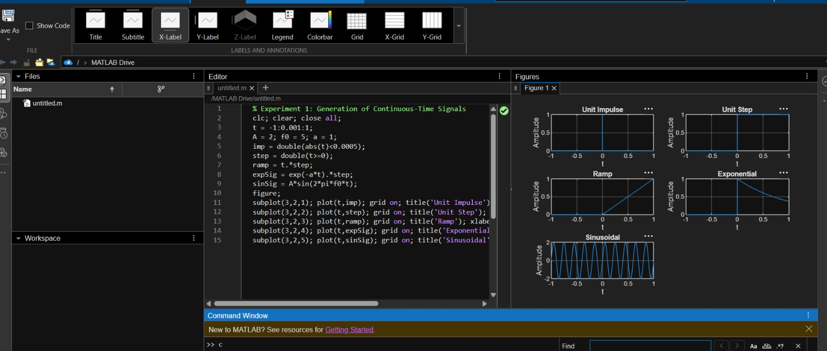
Fig. 1.1 Unit impulse, unit step, ramp, exponential and sinusoidal signals

RESULT
The basic continuous-time signals (unit impulse, unit step, ramp, decaying exponential and sinusoid) were generated and plotted using MATLAB. The sinusoid has an amplitude of 2 V, a frequency of 5 Hz and a period of 0.2 s, which agree with the theoretical values, and all waveforms match their mathematical expressions.

Objective (ii) To generate and visualize basic discrete-time signals and analyze their amplitude and time-index characteristics.
AIM
To generate and visualize basic discrete-time signals and analyze their amplitude and time-index characteristics using MATLAB.
APPARATUS / SOFTWARE REQUIRED
1. Computer / Laboratory PC
2. MATLAB software (with Signal Processing environment)
THEORY
A discrete-time (DT) signal x[n] is defined only at integer values of the index n and is represented graphically by a stem plot. The elementary DT signals are the unit impulse, unit step, ramp, exponential and sinusoidal sequences.
The unit impulse δ[n] equals 1 at n = 0 and 0 elsewhere. The unit step u[n] equals 1 for n ≥ 0. The ramp is r[n] = n·u[n], and the exponential sequence is x[n] = aⁿu[n]. A DT sinusoid x[n] = A sin(2πf₀n) is periodic only if f₀ is a rational number; for f₀ = 0.1 = 1/10, the fundamental period is N₀ = 10 samples.
FORMULAE USED
δ[n] = 1 for n = 0, 0 otherwise; u[n] = 1 for n ≥ 0, 0 otherwise
r[n] = n·u[n]
x[n] = aⁿ u[n] (a = 0.8 in the program)
x[n] = A sin(2πf₀n); periodic if x[n + N₀] = x[n]
Even sequence: x[n] = x[−n]; Odd sequence: x[n] = −x[−n]
ALGORITHM / PROCEDURE
- Start MATLAB and open a new script file.
- Define the integer sample index n = −20 to 20.
- Generate the unit impulse, unit step, ramp, exponential and sinusoidal sequences.
- Display each sequence using a stem plot (subplot) with title and grid.
- Determine the sample amplitudes and the period of the sinusoidal sequence.
- Classify the sequences as periodic / non-periodic and even / odd wherever applicable.
- Compare the generated samples with the theoretical values and record the observations.

PROGRAM (MATLAB CODE)
% Experiment 2: Generation of Discrete-Time Signals
clc; clear; close all;
n = -20:20;
A = 2; f0 = 0.1; a = 0.1;
imp = double(n==0);
step = double(n>=0);
ramp = n.*step;
expSig = (0.8).^n .* step;
sinSig = A*sin(2*pi*f0*n);
figure;
subplot(3,2,1); stem(n,imp,'filled'); grid on; title('Unit Impulse');
subplot(3,2,2); stem(n,step,'filled'); grid on; title('Unit Step');
subplot(3,2,3); stem(n,ramp,'filled'); grid on; title('Ramp');
subplot(3,2,4); stem(n,expSig,'filled'); grid on; title('Exponential');
subplot(3,2,5); stem(n,sinSig,'filled'); grid on; title('Discrete Sinusoid');
xlabel('n');
OUTPUT
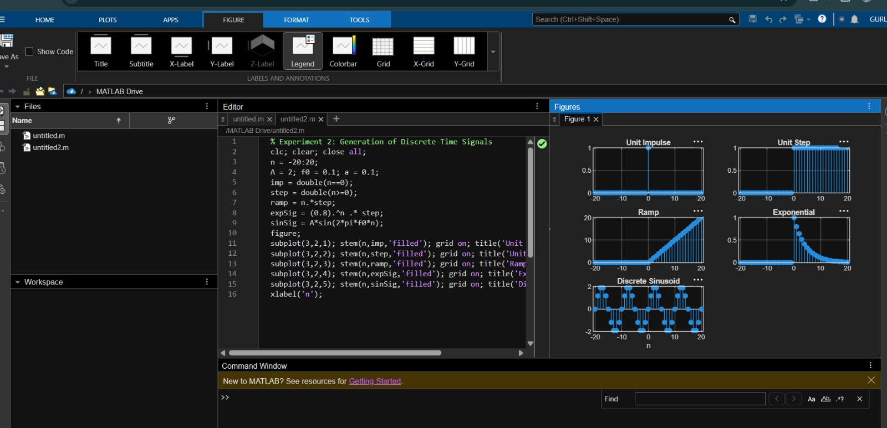

Fig. 1.2 Unit impulse, unit step, ramp, exponential and discrete sinusoid (stem plots)

RESULT
The basic discrete-time sequences (unit impulse, unit step, ramp, exponential and sinusoid) were generated and displayed as stem plots in MATLAB. The sinusoidal sequence with f₀ = 0.1 is periodic with a fundamental period of 10 samples, and all generated samples agree with their theoretical expressions.

Objective | Assessment Criterion | Excellent – 4 | Good – 3 | Satisfactory – 2 | Needs Improvement – 1 | Weightage | Marks(10) | Marks obtained
1. Generate and visualize basic continuous-time signals such as unit step, unit impulse, ramp, sinusoidal and exponential. | CT Signal Generation & MATLAB Implementation | Generates all five CT signals accurately with a suitable time vector and step size. Uses correct MATLAB commands . Plots are correctly scaled, with titles, axis labels and grid. | Generates the required CT signals and plots correctly, with minor errors in code, time range, parameters or labelling. | Generates basic CT signals but has noticeable errors in code, step or impulse representation, or plots, and needs assistance. | Unable to generate the required CT signals or produce meaningful plots. | 25 | 2.5
2. Generate and visualize basic discrete-time signals such as unit sample, unit step, ramp, sinusoidal and exponential sequences. | DT Signal Generation & MATLAB Implementation | Generates all five DT sequences accurately with a proper index vector n. Uses stem correctly. Plots are correctly scaled, with titles, axis labels and grid. | Generates the required DT sequences and plots correctly, with minor errors in index range, stem usage, parameters or labelling. | Generates basic DT sequences but has noticeable errors in code, indexing or stem plots, and needs assistance. | Unable to generate the required DT sequences or produce meaningful stem plots. | 25 | 2.5
3. Classify CT and DT signals as periodic or aperiodic and identify their waveform characteristics. | Signal Classification & Periodicity Analysis | Correctly classifies all signals using DT. Determines the period where applicable. Identifies frequency, phase, and growth or decay. Explains the reasoning clearly with mathematical conditions and waveform evidence. | Classifies most signals correctly and finds most periods, with minor errors or limited justification. | Gives basic classifications. Period calculation or justification is incomplete and needs guidance. | Unable to classify the signals correctly or justify the classification. | 25 | 2.5
4. Analyze the amplitude and time-index characteristics of discrete-time signals. | Amplitude & Time-Index Analysis | Correctly determines maximum and minimum amplitude, the index n at which each occurs, and signal energy. Correctly shows the effect of time shifting and folding on the index. Interprets the results clearly. | Analyzes most amplitude and index characteristics correctly, with minor errors in values or interpretation. | Gives basic amplitude and index analysis with noticeable errors, and needs guidance. | Unable to analyze the amplitude and time-index characteristics or interpret the results. | 25 | 2.5
 |  |  |  |  | Total | 100 | 10

LABORATORY PERFORMANCE ASSESSMENT RUBRICS:

